To View Your Assignment Notice for Current Fiscal Year
Click on FCPS Menu
Under Employee Self Service, click on Personnel Information
. 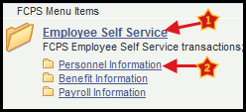
Click Assignment Information

